Mars China

China SMS Sender
(Formerly known as BEES)

Support & Operation

Table Of Contents

1 Table Of Contents 2
2 Modification History 5
3 Document Assumptions / Notes 5
4 Environment Overview 6
4.1 SAP BW 6
4.1.1 Report Details 6
4.2 Notes Agent 7
4.2.1 Individual Tier Details 7
4.3 ICS (Interface Control System) 7
4.3.1 Individual Tier Details 7
4.3.2 Database Users and Descriptions 7
5 Report Contents 9
5.1 Daily SMS - Total China – Snackfood (Y135_DAILY_SMS_ALL_SF) 9
5.1.1 Report Dimensions 9
5.1.2 XML File Contents 9
5.1.3 Report Filters 10
5.2 Daily SMS - Total China – Petcare (Y135_DAILY_SMS_ALL_PC) 10
5.2.1 Report Dimensions 10
5.2.2 XML File Contents 11
5.2.3 Report Filters 12
5.3 Daily SMS - Forecast – Snackfood (Y135_DAILY_SMS_FCST_SF) 12
5.3.1 Report Dimensions 12
5.3.2 XML File Contents 13
5.3.3 Report Filters 13
5.4 Daily SMS - Forecast – Petcare (Y135_DAILY_SMS_FCST_PC) 13
5.4.1 Report Dimensions 13
5.4.2 XML File Contents 14
5.4.3 Report Filters 14
6 Database Structure 15
6.1 Database Overview 15
6.1.1 SMS 15
6.1.1.1 SMS_ABBREVIATION 15
6.1.1.2 SMS_FILTER 16
6.1.1.3 SMS_MESSAGE 16
6.1.1.4 SMS_MES_LINE 16
6.1.1.5 SMS_PROFILE 16
6.1.1.6 SMS_PRO_FILTER 17
6.1.1.7 SMS_PRO_MESSAGE 17
6.1.1.8 SMS_PRO_RECIPIENT 17
6.1.1.9 SMS_QUERY 17
6.1.1.10 SMS_RECIPIENT 17
6.1.1.11 SMS_RPT_DATA 18
6.1.1.12 SMS_RPT_EXECUTION 18
6.1.1.13 SMS_RPT_HEADER 18
6.1.1.14 SMS_RPT_MESSAGE 18
6.1.1.15 SMS_RPT_RECIPIENT 19
6.1.1.16 SMS_SYSTEM 19
6.1.2 SMS_APP 19
6.1.2.1 SMS_FROM_XML 19
6.1.2.2 SMS_TO_DATE 19
6.1.2.3 SMS_TO_NUMBER 19
6.1.2.4 SMS_TO_XML 20
6.1.2.5 SMS_ABB_FUNCTION 20
6.1.2.6 SMS_FLT_FUNCTION 20
6.1.2.7 SMS_GEN_FUNCTION 20
6.1.2.8 SMS_MSG_FUNCTION 20
6.1.2.9 SMS_PARAMETER 21
6.1.2.10 SMS_PRF_FUNCTION 21
6.1.2.11 SMS_QRY_FUNCTION 21
6.1.2.12 SMS_RCP_FUNCTION 21
6.1.2.13 SMS_REP_FUNCTION 21
6.1.2.14 SMS_REP_POLLER 22
6.1.2.15 SMS_SBWSMS01 22
7 ICS Report Generation 23
7.1 Loading from ICS 23
7.1.1 Oracle Objects 23
7.2 Generate Report Messages 23
7.2.1 Oracle Objects 23
7.3 Send SMS Message 24
7.3.1 Multiple Messages (Split Message) 24
7.3.2 Oracle Objects 25
8 China SMS ICS Webpage 26
8.1 ICS Interface 26
8.2 ICS Jobs 26
8.2.1 INBOUND_SMS 26
8.2.2 SMS_DAILY_MAINTENANCE 26
8.2.3 SMS_PERIOD_MAINTENANCE 26
8.2.4 SMS_POLLER 27
8.2.4.1 Loaded 27
8.2.4.2 Processed 27
8.2.4.3 Resent 27
8.2.4.4 Cancelled 27
8.2.4.5 Submitted 27
8.2.4.6 Executing 27
8.3 ICS Logging 27
8.4 SMS Administration Webpage’s 29
8.4.1 Selection Screens 29
8.4.2 Query Selection Screens 30
8.4.3 System Control 31
8.4.3.1 Stop System 31
8.4.3.2 Start System 31
8.4.3.3 Broadcast List 31
8.4.4 System Maintenance 32
8.4.4.1 SMTP Target 32
8.4.4.2 SMTP Host 32
8.4.4.3 SMTP Port 32
8.4.4.4 Report Generation Alert 32
8.4.4.5 Report Generation Email Group 32
8.4.4.6 Query Daily Checker Alert 32
8.4.4.7 Query Daily Checker Email Group 32
8.4.4.8 Query Daily Checker History Days 32
8.4.4.9 Abbreviation Report Email Group 32
8.4.4.10 Recipient Audit Report Email Group 32
8.4.4.11 SMS Broadcast Time (HH24MISS) 33
8.4.5 Query Maintenance 33
8.4.5.1 Query Code 33
8.4.5.2 Query Name 33
8.4.5.3 Query Status 33
8.4.5.4 Query SMS Subject 33
8.4.5.5 Query Monitor Days 33
8.4.5.6 Dimension Levels (1 to 9) 34
8.4.5.7 Dimension Level (x) Name 34
8.4.6 Recipient Maintenance 34
8.4.6.1 Recipient Code 34
8.4.6.2 Recipient Name 34
8.4.6.3 Recipient Status 34
8.4.6.4 Mobile Phone 34
8.4.6.5 Email Address 34
8.4.7 Message Maintenance 35
8.4.7.1 Message Code 35
8.4.7.2 Message Name 35
8.4.7.3 Message Status 35
8.4.7.4 Query 35
8.4.7.5 Message Line Definitions 35
8.4.8 Filter Maintenance 37
8.4.8.1 Filter Code 37
8.4.8.2 Filter Name 37
8.4.8.3 Filter Status 37
8.4.8.4 Query 37
8.4.8.5 Dimension Filters 37
8.4.9 Profile Maintenance 38
8.4.9.1 Profile Code 38
8.4.9.2 Profile Name 38
8.4.9.3 Profile Status 38
8.4.9.4 Query 38
8.4.9.5 Message Send Days 39
8.4.9.6 Selected Recipients 39
8.4.9.7 Selected Filters 39
8.4.9.8 Selected Messages 39
8.4.10 Abbreviation Maintenance 39
8.4.10.1 Abbreviation 39
8.4.11 Report Execution 40
8.4.11.1 Report Date 40
8.4.11.2 Execution Date 40
8.4.11.3 Report Status 40
8.4.12 Report Enquiry 40
8.4.12.1 Action 41
8.4.12.2 Message 41
8.4.12.3 Text 41
8.4.12.4 Time 41
8.4.12.5 Status 42
8.4.12.6 Profile 42
8.4.12.7 Message 42
8.4.12.8 Filter 42
9 Support Process 43
9.1 Support Structure 43
9.1.1 Initial Communication 43
9.1.2 1st Level Support 43
9.1.3 2nd Level Support 43
9.2 Business SLA 44
9.3 ICS Alert and Warning Emails 44
9.3.1 Missing Abbreviations 44
9.3.2 SMS Daily Maintenance - **WARNING** 44
9.3.3 SMS Reporting – Recipient Audit 45
10 Support FAQ 46
10.1 How do I view the SMS pages in ICS? 46
10.2 SMS messages not received, how do I find the cause? 46
10.2.1 Error sending messages 46
10.2.2 Error in Notes Agent 46
10.3 How do I stop messages sending on a public holiday? 46
10.4 Why doesn’t the total match the contents? 46
10.4.1 Check BW 46
10.4.2 Message Structure 47
10.5 Why can’t I see a total line for some items? 47
10.5.1 Total not defined 48
10.5.2 Single value in total dimension 48
10.6 Why hasn’t the SMS message been sent when ICS has processed the query? 48
10.6.1 System stopped 48
10.6.2 Before broadcast time 48
10.6.3 Subsequent send for the day 48

Modification History

Date | Version | Description | Author
22th July, 2009 | 1.0 | Original - DRAFT | Trevor Keon
29th September, 2009 | 1.1 | Updated with scheduled broadcast time | Trevor Keon
18th December, 2009 | 1.2 | Added additional solutions to known support problems | Trevor Keon

Document Assumptions / Notes

- This document is intended for Mars IS associates who will be providing support for the China SMS solution.
- This document is focused primarily on the operational environment for the China SMS solution and technologies related to its functionality. It does not go into details around Global or Regional systems such as SAP (R/3), ICS/LADS, Lotus Notes, etc.
- The reader should have had some exposure to the following technologies:
  - SAP BW
  - Oracle
- The reader should have a basic understanding of the ICS application and how to navigate the webpage that manages it.

Environment Overview

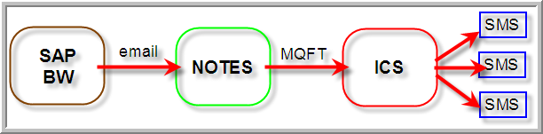
Figure 1 - Environment Overview

SAP BW
The SAP BW system is where the reports are generated and sent from, using the Broadcaster. The Broadcaster generates the BW reports in an XML format at specific times of the day (see below). The XML broadcasts are configured in both BPB (test) and BPP (production).

Report Details
Technical Name | Description | Broadcast Name | Broadcast Time
Y135_DAILY_SMS_ALL_SF | Daily SMS - Total China - Snackfood | Z_RSRD_135_SMS_SLS_SF | 5:30AM
Y135_DAILY_SMS_ALL_PC | Daily SMS - Total China - Petcare | Z_RSRD_135_SMS_SLS_PC | 5:30AM
Y135_DAILY_SMS_FCST_SF | Daily SMS - Total China – Snackfood Fcast | Z_RSRD_135_SMS_FCST_SF | 5:30AM
Y135_DAILY_SMS_FCST_PC | Daily SMS - Total China – Petcare Fcast | Z_RSRD_135_SMS_FCST_PC | 5:30AM
Table 1 - BW Report Details (Note times are WOD)

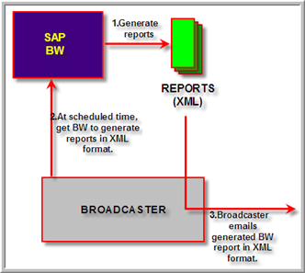
Figure 2 - BW Broadcast Overview

Notes Agent
The Notes Agent is where the BW broadcaster emails the reports. This agent receives the email and then passes it on to ICS using MQFT. It does not do any modifications to the file, just extracts the attached XML file and sends it to ICS. The notes agent will only send the email to ICS if it has the subject “ChinaSMS”.

Individual Tier Details
Tier | Server | Email | Path | Queue Manager
Production | APNTS24 | bw.mqft.link@effem | D:\notes\data\ASIA_PAC\BWCareExchange | APNTS24P
Test | APVN36 | bw.mqft.link.test@effem | D:\Notes\data\dev\ISA\BWCareExchange | CLNT_APVN36T1
Table 2 - Notes Individual Tier Details

Notes link: notes://apsn4/ASIA_PAC/BWMQFTLink.nsf

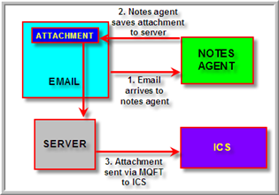
Figure 3 - Notes Agent Overview

ICS (Interface Control System)
The ICS component is used to receive the files from the notes database via MQFT. Once those files have been received and are processed, ICS triggers a job to generate the report for the SMS send, if applicable. It will also manage the SMS sends to the specified users. Refer to China SMS ICS Webpage for more information on the ICS configuration.

Individual Tier Details
Site | Tier | Host | Database | Data/Script Path | Queue Manager
China | Production | APU002 | AP0115P | /ics/lad/prod/ … | APQM002P
China | Test | WODU003 | AP0112T | /ics/lad/test/ … | WODU03T1
Table 3 - ICS Individual Tier Details

Database Users and Descriptions
Database User | Overview / Access / Rights
SMS & SMS_APP | - Stores SMS related data and configurations  - Hosts the packages to do all SMS related tasks, such as generating reports, providing the webpage a means to make configuration changes, and also loading the file from MQFT.
LICS & LICS_APP | - Standard schema for ICS installations  - Provides the logging and alerting functionality
Table 4 - Database Users and Descriptions

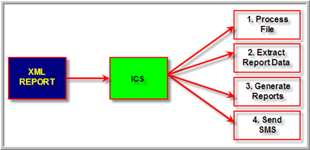
Figure 4 - ICS overview

Report Contents
This section covers each report that is used to send SMS data to the users. It includes information on each column, examples of reports and how to read the XML contents.

Daily SMS - Total China – Snackfood (Y135_DAILY_SMS_ALL_SF)
This report generates all of the sales data for China for the period to date. If it is the first day of the period, then it will send the total sales for the previous period.

Report Dimensions
- Division
- CN – Sold-to SlsTeam (Sales Team)
- SFH Geo Sold (Sales Force Hierarchy)
- CN – BDT

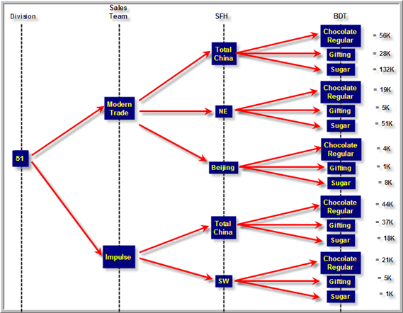
Figure 5 - Snackfood sales report structure

XML File Contents
The contents of the XML file will match directly to the BW report available on the web pages. In the figure below, you can see how to read the XML file so you can find the key information as displayed in the BW report on the web page.
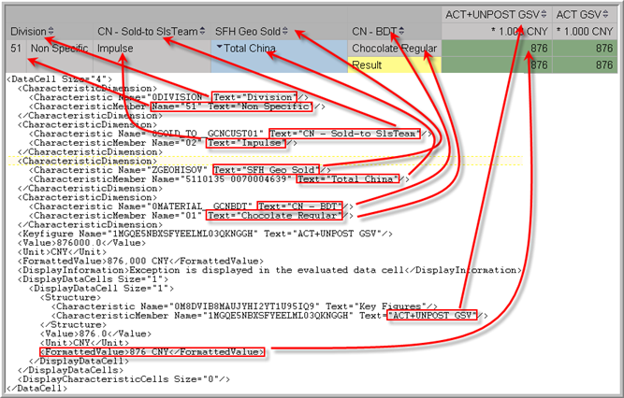
Figure 6 – Snackfood Sales XML file contents compared to WebEX report

Report Filters
The report has a number of filters that cannot be changed by the user. The filter for this report is as follows:

Characteristic | Value | Description
Division | 51 | Non Specific – this is the value for the Snackfood division.
Sales Force Hierarchy Geography Sold | Total China
Company | 135 | Mars Foods (China)
Distribution Channel | 10 | Non Specific
Material Type | FERT | Finished Products
Business Segment | Snackfood
Sales Organisation | 135  234 | Mars Foods (China)  Mars Foods (Jiaxing)
Fiscal year/period | Last 3 periods
Table 5 - Y135_DAILY_SMS_ALL_SF report filters

Daily SMS - Total China – Petcare (Y135_DAILY_SMS_ALL_PC)
This report generates all of the sales data for China for the period to date in Petcare. If it is the first day of the period, then it will send the total sales for the previous period.

Report Dimensions
- Division
- SFH Geo Sold (Sales Force Hierarchy)
- CN – Sold-to SlsTeam (Sales Team)

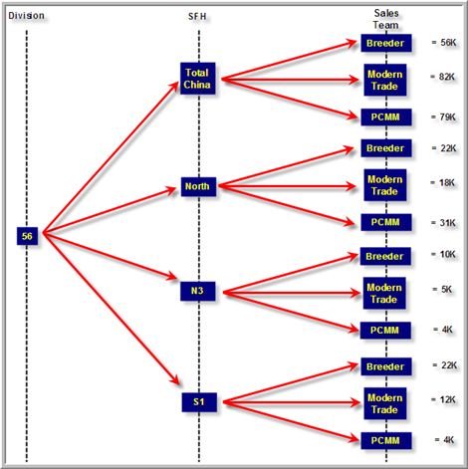
Figure 7 - Petcare sales report structure

XML File Contents
The contents of the XML file will match directly to the BW report available on the web pages. In the figure below, you can see how to read the XML file so you can find the key information as displayed in the BW report on the web page.

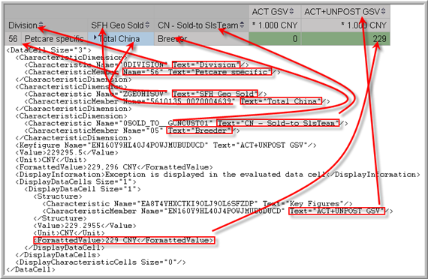
Figure 8 - Petcare Sales XML file contents compared to WebEX report

Report Filters
The report has a number of filters that cannot be changed by the user. The filter for this report is as follows:

Characteristic | Value | Description
Division | 56 | Petcare Specific
Sales Force Hierarchy Geography Sold | Total China
Company | 135 | Mars Foods (China)
Distribution Channel | 10 | Non Specific
Material Type | FERT | Finished Products
Business Segment | Petcare
Sales Organisation | 135  234 | Mars Foods (China)  Mars Foods (Jiaxing)
Fiscal year/period | Last 3 periods
Table 6 - Y135_DAILY_SMS_ALL_PC report filters

Daily SMS - Forecast – Snackfood (Y135_DAILY_SMS_FCST_SF)
This report generates all of the forecast and total sales data for China for the period to date in Snackfood. If it is the first day of the period, then it will send the forecast and total sales for the previous period.

Report Dimensions
- Company
- Division
- CN – BDT

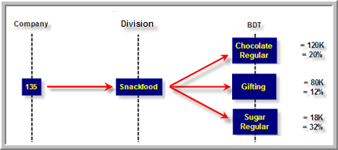
Figure 9 - Snackfood forecast report structure

XML File Contents
The XML contents are in a similar structure as discussed in 5.1.2 and 5.2.2.

Report Filters
The report has a number of filters that cannot be changed by the user. The filter for this report is as follows:

Characteristic | Value | Description
Division | 51 | Non Specific – this is the value for the Snackfood division.
Company | 135 | Mars Foods (China)
Distribution Channel | 10 | Non Specific – this is the value for the Snackfood distribution channel
Material Type | FERT | Finished Products
Business Segment | Snackfood
Sales Organisation | 135  234 | Mars Foods (China)  Mars Foods (Jiaxing)
Fiscal year/period | Last 3 periods
Table 7 - Y135_DAILY_SMS_FCST_SF report filters

Daily SMS - Forecast – Petcare (Y135_DAILY_SMS_FCST_PC)
This report generates all of the forecast and total sales data for China for the period to date in Petcare. If it is the first day of the period, then it will send the forecast and total sales for the previous period.

Report Dimensions
- Company
- Division
- CN – BDT

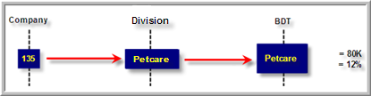
Figure 10 - Petcare forecast report structure

XML File Contents
The XML contents are in a similar structure as discussed in 5.1.2 and 5.2.2.

Report Filters
The report has a number of filters that cannot be changed by the user. The filter for this report is as follows:

Characteristic | Value | Description
Division | 56 | Petcare Specific
Company | 135 | Mars Foods (China)
Distribution Channel | 10 | Non Specific
Material Type | FERT | Finished Products
Business Segment | Petcare
Sales Organisation | 135  234 | Mars Foods (China)  Mars Foods (Jiaxing)
Fiscal year/period | Last 3 periods
Table 8 - Y135_DAILY_SMS_FCST_PC report filters

Database Structure
This section covers details on the architecture of the database to support the generation of SMS messages from BW XML reports.
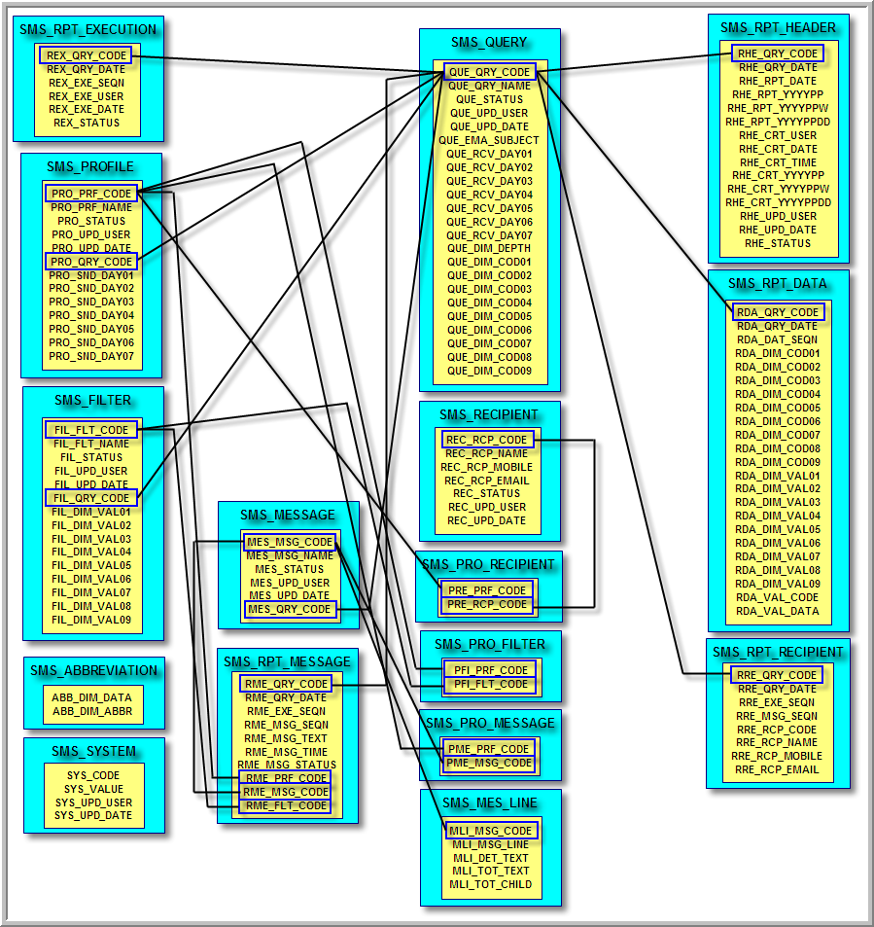
Table 9 – Database structure diagram

Database Overview

SMS
The SMS schema contains all of the tables used to create and store the report information for the SMS messages. The tables in the schema are explained below.

SMS_ABBREVIATION
The SMS_ABBREVIATION table stores the abbreviations used in the SMS messages. The abbreviations can be managed via the ICS webpage Abbreviation Maintenance.

Column Name | Description | Attributes
ABB_DIM_DATA | Dimension data | Primary key
ABB_DIM_ABBR | Dimension abbreviation | Allow null
Table 10 - SMS_ABBREVIATION column details

SMS_FILTER
The SMS_FILTER table stores the information for each filter that can be used in a given profile, based off a given query. The filters can be managed via the ICS webpage Filter Maintenance.

Column Name | Description | Attributes
FIL_FLT_CODE | Filter code | Primary key
FIL_FLT_NAME | Filter name | Cannot be null
FIL_STATUS | Filter status (0=inactive or 1=active) | Cannot be null
FIL_UPD_USER | Filter last updated user | Cannot be null
FIL_UPD_DATE | Filter last updated date | Cannot be null
FIL_QRY_CODE | Query code (refer to SMS_QUERY) | Cannot be null
FIL_DIM_VAL01 - 09 | Dimension 01 – 09 values | Allow null
Table 11 - SMS_FILTER column details

SMS_MESSAGE
The SMS_MESSAGE table stores the information for each message format used in an SMS message. This table doesn’t store each message line detail; that information is in the SMS_MES_LINE table. The message can be managed via the ICS webpage Message Maintenance.

Column Name | Description | Attributes
MES_MSG_CODE | Message code | Primary key
MES_MSG_NAME | Message name | Cannot be null
MES_STATUS | Message status (0=inactive or 1=active) | Cannot be null
MES_UPD_USER | Message last updated user | Cannot be null
MES_UPD_DATE | Message last updated date | Cannot be null
MES_QRY_CODE | Query code (refer to SMS_QUERY) | Cannot be null
Table 12 - SMS_MESSAGE column details

SMS_MES_LINE
The SMS_MES_LINE table stores the line definitions for a given message from the SMS_MESSAGE table. The message lines can be managed via the ICS webpage Message Maintenance in the Message Line Definitions section.

Column Name | Description | Attributes
MLI_MSG_CODE | Message code (refer to SMS_MESSAGE) | Primary key
MLI_MSG_LINE | Message line | Primary key
MLI_DET_TEXT | Message detail SMS text | Cannot be null
MLI_TOT_TEXT | Message total SMS text | Cannot be null
MLI_TOT_CHILD | Message total children (1= All totals, 2=Multiple children totals only) | Cannot be null
Table 13 - SMS_MES_LINE column details

SMS_PROFILE
The SMS_PROFILE table stores the information for each profile that generates a given SMS message. The profiles can be managed via the ICS webpage Profile Maintenance.

Column Name | Description | Attributes
PRO_PRF_CODE | Profile code | Primary Key
PRO_PRF_NAME | Profile name | Cannot be null
PRO_STATUS | Profile status (0=inactive or 1=active) | Cannot be null
PRO_UPD_USER | Profile last updated user | Cannot be null
PRO_UPD_DATE | Profile last updated date | Cannot be null
PRO_QRY_CODE | Query code (refer to SMS_QUERY) | Cannot be null
PRO_SND_DAY01 - 07 | Send SMS Sunday (01) – Saturday (07) (0=no or 1=yes) | Cannot be null
Table 14 - SMS_PROFILE column details

SMS_PRO_FILTER
The SMS_PRO_FILTER table links a list of filters to a given profile. The filters for a profile can be managed via the ICS webpage Profile Maintenance in the Selected Filters section.

Column Name | Description | Attributes
PFI_PRF_CODE | Profile code (refer to SMS_PROFILE) | Primary key
PFI_FLT_CODE | Filter code (refer to SMS_FILTER) | Primary key
Table 15 - SMS_PRO_FILTER column details

SMS_PRO_MESSAGE
The SMS_PRO_MESSAGE table links a list of messages to a given profile. The messages for a profile can be managed via the ICS webpage Profile Maintenance in the Selected Messages section.

Column Name | Description | Attributes
PME_PRF_CODE | Profile code (refer to SMS_PROFILE) | Primary key
PME_MSG_CODE | Message code (refer to SMS_MESSAGE) | Primary key
Table 16 - SMS_PRO_MESSAGE column details

SMS_PRO_RECIPIENT
The SMS_PRO_RECIPIENT table links a list of recipients to a given profile. The recipients for a profile can be managed via the ICS webpage Profile Maintenance in the Selected Recipients section.

Column Name | Description | Attributes
PRE_PRF_CODE | Profile code (refer to SMS_PROFILE) | Primary key
PRE_RCP_CODE | Recipient code (refer to SMS_RECIPIENT) | Primary key
Table 17 - SMS_PRO_RECIPIENT column details

SMS_QUERY
The SMS_QUERY table stores information about a BW query that may be received by the SMS sender. The queries can be managed via the ICS webpage Query Maintenance.

Column Name | Description | Attributes
QUE_QRY_CODE | Query code | Primary key
QUE_QRY_NAME | Query name | Cannot be null
QUE_STATUS | Query status (0=inactive or 1=active) | Cannot be null
QUE_UPD_USER | Query last updated user | Cannot be null
QUE_UPD_DATE | Query last updated date | Cannot be null
QUE_EMA_SUBJECT | Query SMS email subject | Cannot be null
QUE_RCV_DAY01 – 07 | Receive query Sunday (01) – Saturday (07) (0=no or 1=yes) | Cannot be null
QUE_DIM_DEPTH | Query dimension depth | Cannot be null
QUE_DIM_COD01 – 09 | Dimension code 01 – 09 | Allow null
Table 18 - SMS Query column details

SMS_RECIPIENT
The SMS_RECIPIENT table stores information on the users who receive the SMS messages from the SMS sender. The recipients can be managed via the ICS webpage Recipient Maintenance.

Column Name | Description | Attributes
REC_RCP_CODE | Recipient code | Primary key
REC_RCP_NAME | Recipient name | Cannot be null
REC_RCP_MOBILE | Recipient mobile number | Cannot be null
REC_RCP_EMAIL | Recipient email address | Cannot be null
REC_STATUS | Recipient status (0=inactive or 1=active) | Cannot be null
REC_UPD_USER | Recipient last updated user | Cannot be null
REC_UPD_DATE | Recipient last updated date | Cannot be null
Table 19 - SMS_QUERY column details

SMS_RPT_DATA
The SMS_RPT_DATA table stores relevant details extracted from the XML file sent from BW. This table cannot be modified outside of running direct queries on it.

Column Name | Description | Attributes
RDA_QRY_CODE | Query code (refer to SMS_QUERY) | Primary key
RDA_QRY_DATE | Query timestamp | Primary key
RDA_DAT_SEQN | Data sequence | Primary key
RDA_DIM_COD01 – 09 | Dimension 01 – 09 code | Allow null
RDA_DIM_VAL01 – 09 | Dimension 01 – 09 value | Allow null
RDA_VAL_CODE | Value code | Allow null
RDA_VAL_DATA | Value data | Allow null
Table 20 - SMS_RPT_DATA column details

SMS_RPT_EXECUTION
The SMS_RPT_EXECUTION table stores information on the times a query is executed. This information can be viewed via the ICS webpage’s Report Execution and Report Enquiry.

Column Name | Description | Attributes
REX_QRY_CODE | Query code (refer to SMS_QUERY) | Primary key
REX_QRY_DATE | Query timestamp | Primary key
REX_EXE_SEQN | Execution sequence | Primary key
REX_EXE_USER | Execution user | Cannot be null
REX_EXE_DATE | Execution date | Cannot be null
REX_STATUS | Execution status (1=automatic or 2=submitted) | Cannot be null
Table 21 - SMS_RPT_EXECUTION column details

SMS_RPT_HEADER
The SMS_RPT_HEADER table stores header information for a given query from BW. This table cannot be modified outside of running direct queries on it.

Column Name | Description | Attributes
RHE_QRY_CODE | Query code (refer to SMS_QUERY) | Primary key
RHE_QRY_DATE | Query timestamp | Primary key
RHE_RPT_DATE | Report timestamp | Cannot be null
RHE_RPT_YYYYPP | Report Mars period | Cannot be null
RHE_RPT_YYYYPPW | Report Mars week | Cannot be null
RHE_RPT_YYYYPPDD | Report Mars day | Cannot be null
RHE_CRT_USER | Creation user | Cannot be null
RHE_CRT_DATE | Creation date | Cannot be null
RHE_CRT_TIME | Creation time | Cannot be null
RHE_CRT_YYYYPP | Creation Mars period | Cannot be null
RHE_CRT_YYYYPPW | Creation Mars week | Cannot be null
RHE_CRT_YYYYPPDD | Creation Mars day | Cannot be null
RHE_UPD_USER | Updated user | Cannot be null
RHE_UPD_DATE | Updated date | Cannot be null
RHE_STATUS | Report status (1=loaded or 2=processed or 3=resent or 4=cancelled or 5=submitted or 6=executing) | Cannot be null
Table 22 - SMS_RPT_HEADER column details

SMS_RPT_MESSAGE
The SMS_RPT_MESSAGE table stores the historical information on messages that have already been sent to the relevant recipients. This information can be viewed via the ICS webpage Report Enquiry.

Column Name | Description | Attributes
RME_QRY_CODE | Query code (refer to SMS_QUERY) | Primary key
RME_QRY_DATE | Query timestamp | Primary key
RME_EXE_SEQN | Generation sequence | Primary key
RME_MSG_SEQN | Message sequence | Primary key
RME_MSG_TEXT | Message text | Cannot be null
RME_MSG_TIME | Message creation time | Cannot be null
RME_MSG_STATUS | Message status (1=created or 2=sent or 3=error) | Cannot be null
RME_PRF_CODE | Profile code (refer to SMS_PROFILE) | Cannot be null
RME_MSG_CODE | Message code (refer to SMS_MESSAGE) | Cannot be null
RME_FLT_CODE | Filter code (refer to SMS_FILTER) | Cannot be null
Table 23 - SMS_RPT_MESSAGE column details

SMS_RPT_RECIPIENT
The SMS_RPT_RECIPIENT table stores the historical information on recipients who have received a given message. This information can be viewed via the ICS webpage Report Enquiry when the Action is selected.

Column Name | Description | Attributes
RRE_QRY_CODE | Query code (refer to SMS_QUERY) | Primary key
RRE_QRY_DATE | Query timestamp (refer to SMS_RPT_MESSAGE) | Primary key
RRE_EXE_SEQN | Generation sequence (refer to SMS_RPT_MESSAGE) | Primary key
RRE_MSG_SEQN | Message sequence (refer to SMS_RPT_MESSAGE) | Primary key
RRE_RCP_CODE | Recipient code (refer to SMS_RECIPIENT) | Primary key
RRE_RCP_NAME | Recipient name (refer to SMS_RECIPIENT) | Cannot be null
RRE_RCP_MOBILE | Recipient mobile phone number (refer to SMS_RECIPIENT) | Cannot be null
RRE_RCP_EMAIL | Recipient email address (refer to SMS_RECIPIENT) | Cannot be null
Table 24 - SMS_RPT_RECIPIENT column details

SMS_SYSTEM
The SMS_SYSTEM table stores system settings for the SMS sender application. This allows each instance of the SMS sender to be customized as required. The system settings can be managed via the ICS webpage System Maintenance.

Column Name | Description | Attributes
SYS_CODE | System code | Primary key
SYS_VALUE | System value | Cannot be null
SYS_UPD_USER | System last updated user | Cannot be null
SYS_UPD_DATE | System last updated date | Cannot be null
Table 25 - SMS_SYSTEM column details

SMS_APP
The SMS_APP schema contains all of the Oracle objects (packages, functions, etc) used to create and store the report information for the SMS messages. The objects in the schema are explained below.

SMS_FROM_XML
The SMS_FROM_XML function converts text to a format that can be used in XML.

SMS_TO_DATE
The SMS_TO_DATE function converts a given value to a date object, in a specific date format (such as YYYYMMDD).

SMS_TO_NUMBER
The SMS_TO_NUMBER function converts a given value into a number. This also handles negative numbers.

SMS_TO_XML
The SMS_TO_XML function converts data in an XML format to plain text.

SMS_ABB_FUNCTION
The SMS_ABB_FUNCTION package is used to manage abbreviation information in the SMS sender. The package has the following public declarations, and is called from the ICS webpage Abbreviation Maintenance.

Function / Procedure | Description
SELECT_LIST | Returns the list of abbreviations.
RETRIEVE_DATA | Returns a specific abbreviation entry.
UPDATE_DATA | Update a specific abbreviation entry.
Table 26 - SMS_ABB_FUNCTION contents

SMS_FLT_FUNCTION
The SMS_FLT_FUNCTION package is used to manage filter information in the SMS sender. The package has the following public declarations, and is called from the ICS webpage Filter Maintenance.

Function / Procedure | Description
SELECT_LIST | Returns the list of filters.
RETRIEVE_DATA | Returns a specific filter entry.
UPDATE_DATA | Update a specific filter entry.
Table 27 - SMS_FLT_FUNCTION contents

SMS_GEN_FUNCTION
The SMS_GEN_FUNCTION package provides a number of general function and procedures that are used throughout the SMS sender system. The package has the following public declarations.

Function / Procedure | Description
CLEAR_MESG_DATA | Clear message data object.
GET_MESG_COUNT | Get total message data count.
ADD_MESG_DATA | Add message to the data object.
GET_MESG_DATA | Get messages from the data object.
SET_CFRM_DATA | Set the confirmation value in the data object.
RETRIEVE_SYSTEM_CONTROL | Get the status of the system (active or stopped).
UPDATE_SYSTEM_CONTROL | Update the status of the system.
CANCEL_SYSTEM_CONTROL | Cancel a query that is waiting to be sent.
RETRIEVE_SYSTEM_VALUES | Retrieve all system values.
UPDATE_SYSTEM_VALUES | Update a given system value.
RETRIEVE_SYSTEM_VALUE | Retrieve a given system value.
UPDATE_ABBREVIATION | Update a given abbreviation value.
RETRIEVE_ABBREVIATION | Retrieve a given abbreviation value.
DAILY_MAINTENANCE | Run the daily maintenance tasks, such as validate reports have sent.
PERIOD_MAINTENANCE | Run the periodic maintenance tasks, such as email user list.
Table 28 - SMS_GEN_FUNCTION contents

SMS_MSG_FUNCTION
The SMS_MSG_FUNCTION package is used to manage message information in the SMS sender. The package has the following public declarations, and is called from the ICS webpage Message Maintenance.

Function / Procedure | Description
SELECT_LIST | Returns the list of messages.
RETRIEVE_DATA | Returns a specific message entry.
UPDATE_DATA | Update a specific message entry.
Table 29 - SMS_MSG_FUNCTION contents

SMS_PARAMETER
The SMS_PARAMETER package contains constant values for the given environment.

SMS_PRF_FUNCTION
The SMS_PRF_FUNCTION package is used to manage profile information in the SMS sender. The package has the following public declarations, and is called from the ICS webpage Profile Maintenance.

Function / Procedure | Description
SELECT_LIST | Returns the list of profiles.
RETRIEVE_DATA | Returns a specific profile entry.
UPDATE_DATA | Update a specific profile entry.
Table 30 - SMS_PRF_FUNCTION contents

SMS_QRY_FUNCTION
The SMS_QRY_FUNCTION package is used to manage query information in the SMS sender. The package has the following public declarations, and is called from the ICS webpage Query Maintenance.

Function / Procedure | Description
SELECT_LIST | Returns the list of queries.
RETRIEVE_DATA | Returns a specific query entry.
UPDATE_DATA | Update a specific query entry.
Table 31 - SMS_QRY_FUNCTION

SMS_RCP_FUNCTION
The SMS_RCP_FUNCTION package is used to manage recipient information in the SMS sender. The package has the following public declarations, and is called from the ICS webpage Recipient Maintenance.

Function / Procedure | Description
SELECT_LIST | Returns the list of recipients.
RETRIEVE_DATA | Returns a specific recipient entry.
UPDATE_DATA | Update a specific recipient entry.
Table 32 - SMS_RCP_FUNCTION contents

SMS_REP_FUNCTION
The SMS_REP_FUNCTION package is used to manage the generation of SMS messages for a given query. It also contains functionality to view historical information on messages that have been already sent. The package has the following public declarations, and is called from the ICS webpage’s Report Execution and Report Enquiry.

Function / Procedure | Description
SELECT_ENQUIRY | Get a historical list of queries that have been run.
RETRIEVE_REPORT | Get a historical list of reports that have been generated for a given query.
RETRIEVE_MESSAGE | Get a list of messages that have been generated for a given query at a specified time.
RETRIEVE_RECIPIENT | Get a list of recipients that received a given message, for a given query at a specified time.
SELECT_EXECUTION | Get the list of queries that can be executed.
RETRIEVE_EXECUTION | Get the execution details for a given query.
UPDATE_EXECUTION | Submit the given query to be processed and sent.
GENERATE | Generates the message for a given query, date and status.
Table 33 - SMS_REP_FUNCTION

SMS_REP_POLLER
The SMS_REP_POLLER package is used to decide when a query should be processed and sent as an SMS message.

SMS_SBWSMS01
The SMS_SBWSMS01 package extracts the relevant information from the BW XML file. It also updates the status of the query so the poller can execute the new file, unless it is a resend.

ICS Report Generation
This section covers the steps involved in generating the SMS reports that are sent to the user.

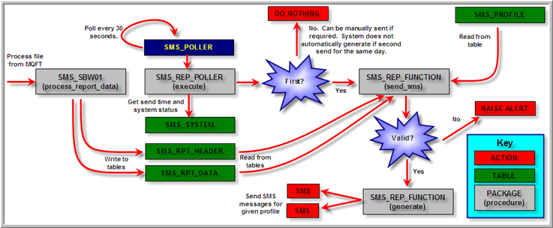
Figure 11 - Report Generation

Loading from ICS
Once the file has been received via MQFT (refer to ICS (Interface Control System) for more information), it is processed and stored in the SMS tables. The poller then decides when to process the query and send the SMS messages. See above for details.

Oracle Objects

Schema | Package | Function/Procedure | Table | Action
SMS_APP | SMS_SBWSMS01 | on_end | SMS_RPT_HEADER | Read
SMS_APP | SMS_SBWSMS01 | process_report_data | SMS_RPT_DATA | Read
Table 34 - ICS processing Oracle objects
Refer to SMS_SBWSMS01 for information on what this package does. To send the SMS messages for a file that has been received on the same day, refer to Report Execution.

Generate Report Messages
The creation of the reports can be triggered in 2 ways. Firstly, it can be done automatically from the poller when it is time (refer to for files received on that day to send. The second way to generate the reports is by manually executing the given report (refer to Report Execution).

Oracle Objects

Schema | Package | Function/Procedure | Table | Action
SMS_APP | SMS_REP_FUNCTION | generate | SMS_RPT_HEADER | Read/Write
SMS_APP | SMS_REP_FUNCTION | generate | SMS_RPT_DATA | Read
SMS_APP | SMS_REP_FUNCTION | generate | SMS_RPT_EXECUTION | Read/Write
SMS_APP | SMS_REP_FUNCTION | generate | SMS_QUERY | Read
SMS_APP | SMS_REP_FUNCTION | generate | SMS_PROFILE | Read
SMS_APP | SMS_REP_FUNCTION | generate | SMS_PRO_MESSAGE | Read
SMS_APP | SMS_REP_FUNCTION | generate | SMS_MESSAGE | Read
SMS_APP | SMS_REP_FUNCTION | generate | SMS_MES_LINE | Read
SMS_APP | SMS_REP_FUNCTION | generate | SMS_PRO_FILTER | Read
SMS_APP | SMS_REP_FUNCTION | generate | SMS_FILTER | Read
SMS_APP | SMS_REP_FUNCTION | generate | SMS_PRO_RECIPIENT | Read
SMS_APP | SMS_REP_FUNCTION | generate | SMS_RECIPIENT | Read
SMS_APP | SMS_REP_FUNCTION | generate | SMS_RPT_MESSAGE | ReadWrite
SMS_APP | SMS_REP_FUNCTION | generate | SMS_RPT_RECIPIENT | ReadWrite
LICS_APP | LICS_LOGGING | write_log | LICS_LOG | Write
Table 35 – Report generation Oracle objects

Send SMS Message
The send of a message only happens when the following conditions are met:

- The query exists in the system and is active
- An active profile exists for the query
- An active filter exists for the profile
- An active message exists for the profile
- There is data for the report
- The data does not just consist of the total
- There are active recipients for the message

If the SMS message is not sent, refer to the ICS log (see ICS Logging) to identify the cause. Note that if there are no active recipients for the message a warning email will be sent to the Report Generation Email Group.

Multiple Messages (Split Message)
The SMS message has a restriction of 160 characters. A white space (space, tab, etc) and new lines also constitute a character and are included in the count of characters. For example, the below message has 32 characters:

N3-P10W1D1
Breeder ( 0K + U76K )

When the message is longer than 160 characters it is split into a new message. You can identify a split message because it always starts with the Message number, and the message part number. For example:

M7P1 N3-P10W1D1
Breeder ( 0K + U76K )
...

The text in bold is called the split text.

Each report can have multiple messages generated from it. The order at which each message is created and delivered is random, which means the first part of a message may not arrive until after the second part arrives. There is also the potential for other messages for the report to be split as well. The message number and part number help identify which message should be joined to another. For example:

M7P1 N3-P10W1D1
Breeder ( 0K + U76K )
...

Does not join with:

M1P2 PCMM ( 0K + U154K )
TOT ( 0K + U1105K )

However does join with:

M7P2 TOT ( 0K + U141K )

The message number is generated when the message is created. Each message for a given report will have its own unique number, and can be viewed on the ICS webpage in the Report Enquiry page. Note that the ICS webpage does not show the message splits, and it is not recorded in the database. Only the message that has been delivered to the recipient’s phone will contain the split text.

The part number is generated each time a message exceeds 160 characters. The first 160 character block will be assigned part 1, the second 160 character block will be assigned part 2, and so on until the message has been sent in full.

Oracle Objects

Schema | Package | Function/Procedure | Table | Action
SMS_APP | SMS_REP_FUNCTION | send_sms | SMS_RPT_RECIPIENT | Read
Table 36 - SMS sending Oracle objects

China SMS ICS Webpage
This section covers the different aspects of the ICS webpage for the China SMS Sender. It will include information around the ICS interfaces, jobs, logging, as well as the China SMS Reporting Administration pages used to configure and monitor the SMS messages.

ICS Interface
An interface is required in ICS to be able to load and process the data for the SMS reports. This interface will accept any XML file provided to it, however if the file is not structured correctly it will raise an alert. See the Email Group below for information on who receives the alert.

Interface | Description | ICS Job | Email Group | Procedure
SBWSMS01 | BW to SMS - Report Interface | IB_SMS | trevor.keon@smtp.ap.mars | sms_app.sbwsms01
Table 37 - Interface configuration details

ICS Jobs
The China SMS Sender has a number of ICS jobs that carry out tasks ranging from running the SMS interface to removing old data (such as old reporting data).

Job | Description | Group/Procedure | Email Group | Interval
INBOUND_SMS | Inbound SMS Report Interface Processor | IB_SMS | "Global ISI ICS-LADS Application Support"@smtp.ap.mars | Polling
SMS_DAILY_MAINTENANCE | SMS Reporting Daily Maintenance | sms_gen_function.daily_maintenance | trevor.keon@smtp.ap.mars | Daily 8:00AM
SMS_PERIOD_MAINTENANCE | SMS Reporting Period Maintenance | sms_gen_function.period_maintenance | trevor.keon@smtp.ap.mars | Periodically Day 1 8:00AM
SMS_POLLER | SMS Broadcast Poller | sms_app.sms_rep_poller.execute | trevor.keon@smtp.ap.mars | 30 seconds
Table 38 - Job configuration details

INBOUND_SMS
The INBOUND_SMS job is used to process any SMS interfaces that arrive, provided the ICS jobs are running.

SMS_DAILY_MAINTENANCE
The SMS_DAILY_MAINTENANCE job runs daily at 8AM (China time) and carries out the following tasks:

- Check the expected queries have arrived. If a query has been configured to run on a Monday and it has not arrived, an alert will be raised by this job.
- Purge query report history older than the value specified in the Query Daily Checker History Days (default is 28 days).
- Generate missing abbreviations report. This is used to identify any text that can be abbreviated to help keep the SMS message under 160 characters. Refer to Abbreviation Maintenance for more information.

SMS_PERIOD_MAINTENANCE
The SMS_PERIOD_MAINTENANCE job runs on the first day of every period at 8AM (China time) and carries out the following tasks:

- Generate recipient audit report. This report should be reviewed to ensure the following:
  - The recipient is still an associate in Mars.
  - The recipient is still in the correct role and should receive the given SMS.
  - The recipient’s phone number is still correct.

SMS_POLLER
The SMS_POLLER job runs every 30 seconds to check if a query needs to be processed and sent. A query will be processed if the following are true:

- The system is active (refer to System Control)
- The broadcast time is passed (refer to SMS Broadcast Time (HH24MISS))
- One or more queries exist with a status of Loaded or Submitted

There are a number of different status values a query can have. These are explained below.

Loaded
The loaded status indicates a query that has been received for the first time in the current day. If the system is active, this query will be automatically processed.

Processed
The processed status indicates a query that has been processed successfully. SMS messages will have been sent to the specified recipients.

Resent
The resent status indicates a query that has been received, but not for the first time in the current day. This query can only be processed manually (refer to Report Execution).

Cancelled
The cancelled status indicates a query that has been received, but was cancelled in the System Control screen before it could be processed. Once a query has been cancelled it cannot be processed.

Submitted
The submitted status indicates a query has been submitted to the poller for processing. The query cannot be prevented from running once it reaches this status.

Executing
The executing status indicates the poller is currently processing the query.

ICS Logging
The ICS logging is crucial to assist in identifying any support issues, and to ensure everything was run as expected. Any errors or warnings will be logged in ICS for a variety of tasks. The type of logging that can be found in ICS for the China SMS Sender is as follows:

- SMS report generation
- SMS daily maintenance
- SMS period maintenance

Any user can access ICS logging, so you do not need to organise special access to view the information. To view the logs, follows the steps below:

- Connect to the ICS browser (http://webappdev11.ap.mars/ics_browser.asp)
- Select the relevant environment.

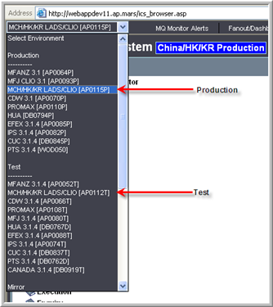
- Select Monitoring -> Log Monitoring
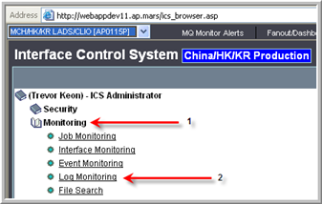
- Select the log to view. Note that there can be multiple entries for the same type of log. Ensure you know the approximate time the log would have been generated at to assist in finding the correct log. You can also search using the Log Search shown below.
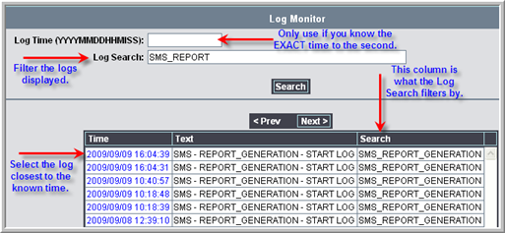
- The log contents are then shown in a new window.

SMS Administration Webpage’s
The SMS administration webpage’s are accessed from the ICS webpage (see below). The user needs to be given the correct access to view this section of the ICS webpage. Refer to the support FAQ (How do I view the SMS pages in ICS?) for more information on gaining access to the SMS webpage’s.

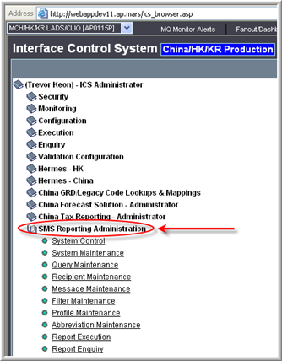
Figure 12 - Accessing SMS Administration Webpage

The following webpage’s exist to support the China SMS Sender:

- System Control
- System Maintenance
- Query Maintenance*
- Recipient Maintenance*
- Message Maintenance*
- Filter Maintenance*
- Profile Maintenance*
- Abbreviation Maintenance*
- Report Execution
- Report Enquiry

The pages with an asterisk’s (*) have a selection page associated with them. The selection pages are similar in design, and are described in detail in Selection Screens.

Selection Screens
The selection screens allow the user to navigate to the item they want to either update or copy. It also allows the user to create a new item.
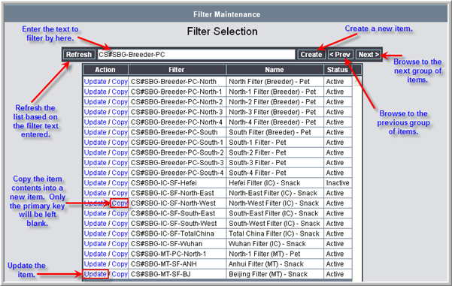
Figure 13 - SMS Selection Screen
If the filter text is blank, then a refresh will start from the first item in the list. Each selection screen shows a maximum of 20 items per page. If there are less than 20 items then the previous and next buttons will have no effect.

When Update, Copy or Create are selected, the items edit screen will be displayed, which are described individually in their respective sections below. Note that not all of the SMS webpage’s have an associated selection screen (such as the System Control page).

Query Selection Screens
The query selection screens allow the user to navigate to the item they want to select. Although in some cases there is a create option, it has no effect.
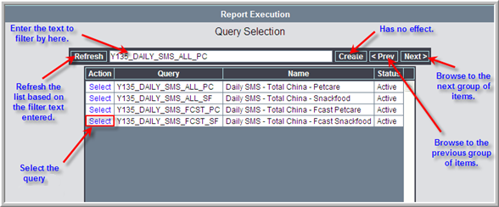
Figure 14 - SMS Query Selection Screen
If the filter text is blank, then a refresh will start from the first item in the list. Each selection screen shows a maximum of 20 items per page. If there are less than 20 items then the previous and next buttons will have no effect.

When Select is selected, the next action is described individually in their respective sections below. Note that not all of the SMS webpage’s have an associated query selection screen (such as the System Control page).

System Control
The System Control webpage allows the user to start or stop the SMS report generation. The current status of the system is also displayed on this webpage. It also gives the user the ability to remove pending queries that have not been processed yet. This can be useful for support purposes.

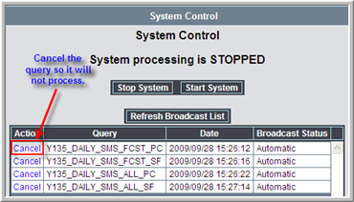
Figure 15 - SMS System Control Webpage

Stop System
When the system is stopped, all processing of SMS reports is prevented. If a job is currently running when the system is stopped it will not be interrupted. This feature can be useful if there is scheduled maintenance or public holidays when users do not want to receive the SMS message. Clicking Stop System while the system is already stopped has no impact.

Start System
Once the system has been started it will process any backlog that can be viewed in the Broadcast List. Any subsequent messages will then be processed as normal.

Broadcast List
The broadcast list displays any queries that are waiting to be processed. The SMS_POLLER runs every 30 seconds, so that is as long as a query will be displayed in this list. If the system is stopped, then they will be displayed until the system starts and the poller runs. The list is processed in a FIFO (First In First Out) approach.

Cancel
The cancel option will prevent the select query from running. Once a query has been cancelled it cannot be processed again until a new file is sent to ICS.

Query
Displays the query that the pending file is associated with.

Date
Displays the date and time the query was received at.

Broadcast Status
Displays the status of the given entry. The status can be one of the following:

- Automatic – indicates a file that has been received from ICS.
- Manual – indicates a file that has been reprocessed.

System Maintenance
The System Maintenance webpage allows the user to configure various settings used by the SMS Sender.

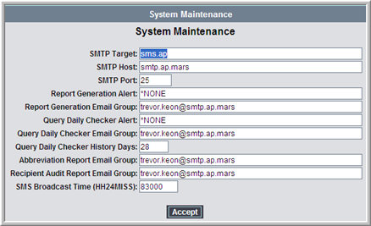
Figure 16 - SMS System Maintenance Webpage

SMTP Target
Specify’s the SMTP server to use when sending SMS messages.

SMTP Host
Specify’s the SMTP server to use when sending emails.

SMTP Port
Specify’s the port to use for SMTP sending (for both email and SMS).

Report Generation Alert
Raises a magic ticket with the specified text when an error occurs during the report generation. Set to *NONE to send no alerts.

Report Generation Email Group
Sends an email with details on any errors that occurred during a report generation.

Query Daily Checker Alert
Raises a magic ticket with the specified text when an error occurs during the SMS_DAILY_MAINTENANCE job. Set to *NONE to send no alerts.

Query Daily Checker Email Group
Sends an email with details on any errors that occurred during the SMS_DAILY_MAINTENANCE job.

Query Daily Checker History Days
Specify’s how many days of report generation history to keep before it is removed.

Abbreviation Report Email Group
Sends an email with any abbreviations that are not set in the system.

Recipient Audit Report Email Group
Sends an email with all the users who are currently receiving the SMS reports. Refer to SMS_PERIOD_MAINTENANCE for more information.

SMS Broadcast Time (HH24MISS)
Specify’s the time that the system generates and sends the SMS messages that are loaded. This is based on the system time, which is not necessarily the local time.

Query Maintenance
The Query Maintenance webpage has a selection screen associated with it. Refer to Selection Screens for information on how to navigate the initial webpage that is displayed. Once the user has navigated to the editing webpage, the following is displayed:

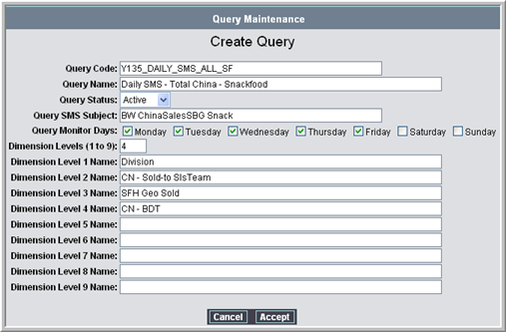
Figure 17 - SMS Query Maintenance Webpage

Query Code
This is unique code to identify each query that is received from SAP BW. This must be named after the technical name of the query sent from BW. For example, in the above image it is referring to the Daily SMS - Total China – Snackfood (Y135_DAILY_SMS_ALL_SF) query.

Query Name
This describes the query that is received from SAP BW. For ease of reference, it should be the same as the BW query description it is receiving. For example, in the above image it is referring to the Daily SMS - Total China – Snackfood (Y135_DAILY_SMS_ALL_SF) query.

Query Status
Set whether the query is active or not. If the query is inactive then it should not be getting any broadcasts sent from SAP BW or it will result in an alert being raised. Set to inactive only when the query has been retired and no longer in use.

Query SMS Subject
This defines the subject set in the SMS message. Although this text will not show in the SMS message received on the phone, it is critical that the subject starts with the BW text. If the BW text is not at the start of the subject the message will be blocked from the SMS gateway.

Query Monitor Days
Select the days the query is sent from BW. If the file is received from BW and the query is not set to run on that day, it will be ignored. If the file is not received from BW and the query is set to run on that day, it will be included in the SMS_DAILY_MAINTENANCE alert email.

Dimension Levels (1 to 9)
Set to the number of dimensions in the BW query. If it does not match the number of dimensions in the BW report then those missing dimensions will be ignored or result in invalid text being included in the SMS message. The query cannot be saved if the number specified here doesn’t match the number of items entered in each individual dimension level (refer to Dimension Level (x) Name).

Dimension Level (x) Name
Enter the name of the dimensions at the “x” level (1 to 9). Although it does not have to match the name in the report, it is recommended to make support easier.

Recipient Maintenance
The Recipient Maintenance webpage has a selection screen associated with it. Refer to Selection Screens for information on how to navigate the initial webpage that is displayed. Once the user has navigated to the editing webpage, the following is displayed:

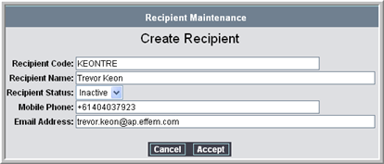
Figure 18 - SMS Recipient Maintenance Webpage

Recipient Code
Unique code to identify the recipient of the message and should be the users 5/3.

Recipient Name
Set to the name of the recipient who is receiving the message.

Recipient Status
This represents the status of the recipient. If it is set to inactive then the recipient will not receive any messages, even if they are assigned to a profile.

Mobile Phone
Set the recipients mobile phone number, including area code. If the area code is not set, then there is a chance the message will not send to the intended individual. Note that the mobile number must not contain any spaces.

Email Address
Set the recipients email address. The system does not use this address for any purpose, however it can be useful if the recipient needs to be contacted for support reasons.

Message Maintenance
The Message Maintenance webpage has a selection screen associated with it. Refer to Selection Screens for information on how to navigate the initial webpage that is displayed. Once the user has navigated to the editing webpage, the following is displayed:

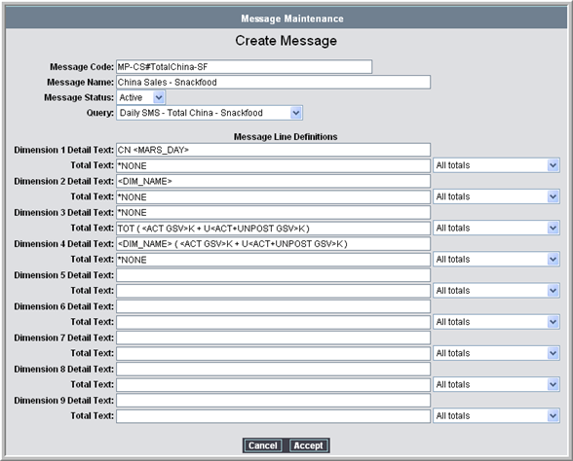
Figure 19 - SMS Message Maintenance Webpage

Message Code
This is a unique code to identify the message that is generated from a given query.

Message Name
This describes the message purpose and should include details on the business segment.

Message Status
This specify’s the status of the message, and will define whether the message is used or not. If the message is set to inactive it will not be used to generate an SMS message.

Query
Select the query that the message should be associated with. The Message Line Definitions must match the number of dimensions specified in the Dimension Levels (1 to 9) in the query.

Message Line Definitions
This section is where the structure of the SMS message is defined. If text is added at the wrong dimension then the message contents will not show as expected. For the above example, the below SMS message was produced:

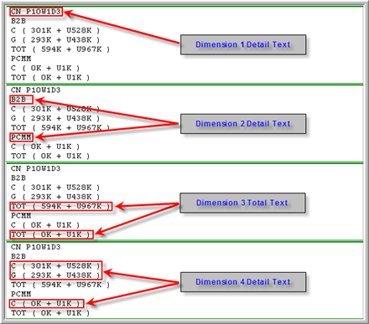
Figure 20 - Message output and location of definitions

Pre-defined Tags
The following tags are configured automatically from the data provided in the BW XML file:

- <MARS_DAY> - The period, week and day the report was generated for in the format P10W1D3.
- <DIM_NAME> - The name provided for the dimension at the level specified. You cannot have the dimension name from a different level displayed.

Custom Tags
The custom tags are extracted from the key figures in the BW report. The key figures represent the fact columns of a BW report, such as Actual GSV, Target GSV, etc. The tags must match the exact text of the key figure to be converted to the expected values. The custom tags in the above example are as follows:

- <ACT GSV>
- <ACT+UNPOST GSV>

Total Text Options
The Total Text fields have a drop-down box, which allow you to select from the following:

- All totals
- Multiple children totals only

The second option will only show the total text when there are multiple detail lines for that dimension. Using the previous message example, the message would change as follows:

CN P10W1D3
B2B
C ( 301K + U528K )
G ( 293K + U438K )
TOT ( 594K + U967K )
PCMM
C ( 0K + U1K )
TOT ( 0K + U1K )

The total line is removed in the above example because there is just the single detail line for that dimension, thus the total value will match the detail line.

Filter Maintenance
The Filter Maintenance webpage has a selection screen associated with it. Refer to Selection Screens for information on how to navigate the initial webpage that is displayed. Once the user has navigated to the editing webpage, the following is displayed:

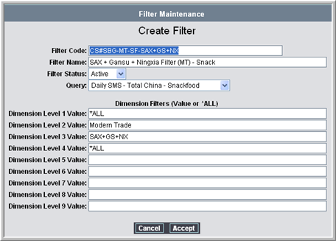
Figure 21 - SMS Filter Maintenance Webpage

Filter Code
This is a unique code to identify the filter. If possible, it should include what is being filtered in this code.

Filter Name
This describes what the filter is filtering by.

Filter Status
Set whether the filter is active or inactive. If the value is set to inactive, this filter will not be used if assigned to a profile.

Query
Specify which query this filter is assigned to. This will dictate how many dimensions levels must include a value.

Dimension Filters
Set the value to filter by at each level, or *ALL if there is nothing to filter by at that given level. In the above example, the filter will result in showing only Modern Trade sales team data for the SAX, Gansu and Ningxia provinces. An example output from this filter is shown below:

MT ( SAX+GS+NX ) P10W2D2
C ( 1K + U3058K )
G ( 14K + U619K )
S ( 1K + U-3K )
TOT ( 15K + U3674K )

Profile Maintenance
The Profile Maintenance webpage has a selection screen associated with it. Refer to Selection Screens for information on how to navigate the initial webpage that is displayed. Once the user has navigated to the editing webpage, the following is displayed:

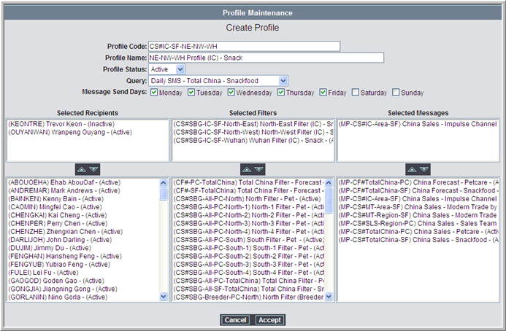
Figure 22 - SMS Profile Maintenance Webpage
The profile maintenance screen is where everything comes together and is what the SMS messages are generated from. If a recipient, filter or message is not in a profile, then it has no impact to the system.

Profile Code
This is a unique code to identify the profile. If possible, it should identify what type of message the profile will produce.

Profile Name
This is a short description on the profile and what type of message it will produce.

Profile Status
Set whether the profile is active or inactive. If the value is set to inactive, this profile will not be run when generating the SMS messages.

Query
Specify which query this profile is to run from. When a file arrives from ICS, the system will get each profile for the query that file is associated with. If the query is not set correctly the message will not be sent as expected. The filters and messages must also be assigned to the same query.

Message Send Days
Set the days this profile should send a message. The SMS_DAILY_MAINTENANCE task uses this information when generating the warning email in regards to missing queries on the given day.

Selected Recipients
This section allows the user to add or remove recipients for the profile. The selection boxes allow multiple selections by pressing the CTRL or SHIFT key when selecting a recipient. You can add recipients that are inactive, however they will not be sent the message.

Selected Filters
This section allows the user to add or remove filters for the profile. The selection boxes allow multiple selections by pressing the CTRL key when selecting a filter. You can add filters that are inactive, however a message will not be generated from that filter. An SMS message is generated for each filter provided. The system does not join the filters together to create a single SMS message.

Selected Messages
This section allows the user to add or remove messages for the profile. The selection boxes allow multiple selections by pressing the CTRL key when selecting a message. You can add messages that are inactive, however that message will not be generated. An SMS message is generated for each message provided.

Note: if you have multiple recipients, filters and messages the profile will generate a multiple of each selection in SMS messages. Using the above example, and assuming all recipients where active, there would be a total of 6 SMS messages produced (3 for each recipient). If there were an additional message in the above example, then there would be 12 SMS messages produced (6 for each recipient).

Abbreviation Maintenance
The Abbreviation Maintenance webpage has a selection screen associated with it. Refer to Selection Screens for information on how to navigate the initial webpage that is displayed. Once the user has navigated to the editing webpage, the following is displayed:

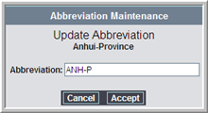
Figure 23 - SMS Abbreviation Maintenance Webpage
The abbreviation maintenance screen allows the user to change dimension values to be shorter, which will make it easier to fit the data into a single SMS message. Refer to Multiple Messages (Split Message) for more information.

The user can only update existing abbreviations, not create new ones. All dimension data values are added to the abbreviation table, if they do not exist already, once the file from ICS has been processed. The user can then update the new abbreviation if required using this screen.

Abbreviation
Set the abbreviation for the given dimension data. In the above example, the Anhui-Province dimension data has been changed to ANH-P.

Report Execution
The Report Execution webpage has a query selection screen associated with it. Refer to Query Selection Screens for information on how to navigate the initial webpage that is displayed. Once the user has navigated to the query they wish to execute, the following is displayed:

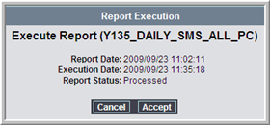
Figure 24 – SMS Report Execution Webpage
The report execution screen allows the user to reprocess queries and resend the SMS messages. Once the Accept button has been clicked, the SMS message will be sent for all associated active profiles.

Report Date
The date the report was loaded into the system. This date will not change until a new query is processed in the system.

Execution Date
The date the report was last created and sent.

Report Status
The current status of the report, which is explained in more detail in the SMS_POLLER section.

Report Enquiry
The Report Enquiry webpage has a query selection screen associated with it. Refer to Query Selection Screens for information on how to navigate the initial webpage that is displayed. Once the user has navigated to the query they wish to review, the following is displayed:
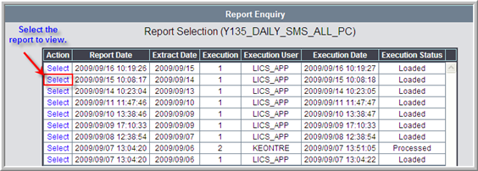
Figure 25 - SMS Report Enquiry Selection Webpage
The selection webpage allows the user to view message sent on previous days. The total number of days shown is based on the Query Daily Checker History Days value.

Once the user has selected the query to view, the following is displayed:

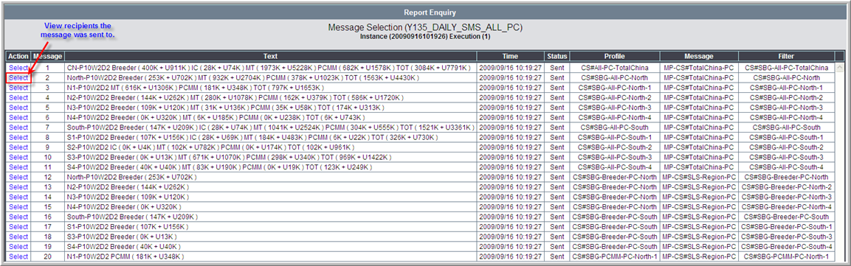
Figure 26 - SMS Report Enquiry Webpage

Action
View the recipients the message was sent to.

Message
This column displays the message number, and is used for Multiple Messages (Split Message).

Text
This column displays the text that makes up the contents of the SMS messages. Note that it does not include any carriage returns (enter).

Time
This column displays the time the message was generated and sent at.

Status
This column displays the status of the message.

Profile
This column displays the profile that was used to generate the SMS message.

Message
This column displays the message that was used to format the SMS message.

Filter
This column displays the filter that was used to specify the information shown in the SMS message.

Once the user clicks on Select in the Action column, the following screen is displayed:

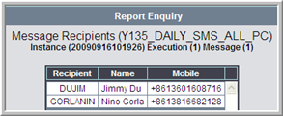
Figure 27 - SMS Report Enquiry Recipient Webpage
This simply shows the details of the recipients who where sent the SMS message for the given message number, execution and instance.

Support Process
This section covers the process to follow with any support related issue. It also covers the business SLA and the standard ICS alert and warning emails that are generated on a day-to-day basis.

Support Structure
The support structure is defined as follows:

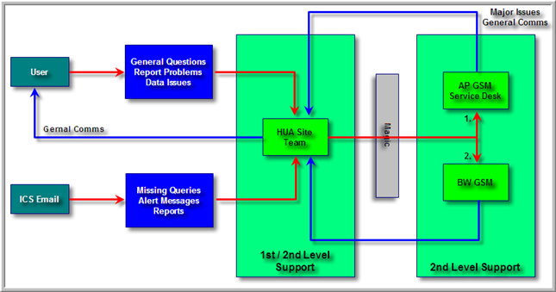
Figure 28 - Support Structure

Initial Communication
The initial communication is provided either from a user, or an automated alert email from ICS. All communication is directed to the 1st level support, being the HUA Site Team.

1st Level Support
The 1st level support provides the point of contact for user issues, questions or email alerts. They should have the required knowledge to assist the user with their enquiry and also know how to escalate anything that they do not support. Escalation should be carried out in the following steps:

- Investigate the issue in the China SMS Sender to ensure the problem did not originate at that point.
- Raise a magic ticket to the AP GSM Service Desk group with details on the issue. Support them as required. They are responsible for supporting the following:
  - ICS (Interface Control System) (this does not include the China SMS administration area)
  - Notes Agent, and the flow of data from it to ICS.
- If the issue does not originate from anything the AP GSM Service Desk supports, forward the magic ticket to the BW GSM group.
- Contact the BW dispatcher on sametime so they are aware of the issue. They are responsible for supporting the following:
  - SAP BW

2nd Level Support
The 2nd level support provides the technical support in the areas they are responsible for. Note that the HUA Site Team is also part of this level as they provide technical support for the China SMS Sender.

Business SLA
The business SLA (Service Level Agreement) is for the SMS messages to reach the users no later than 8:30AM HUA time. All issues should have an incident raised with the urgency dictating the SLA for resolution. The resolution time for each level of urgency is defined in the Magic system, and can be found by speaking to your Magic Functional Expert.

The main business contacts for the China SMS Sender are Joyce Li and Patricia Zhao.

ICS Alert and Warning Emails
ICS will generate alerts or warning emails when certain conditions are met. Some of these emails are part of the day-to-day operation of the China SMS Sender (such as the Missing Abbreviations) while others will only be sent if there is a critical issue (such as the BW files not arriving in time).

Missing Abbreviations
The missing abbreviations email is generated from the SMS_DAILY_MAINTENANCE job and contains a list of abbreviations that have not been defined. An example extract from the spreadsheet can be seen below:

SMS Reporting - Missing Abbbreviations Report - 2009/09/15
Dimension Data
*TOTAL
ANH
B2B
BJ
Breeder
CQ+Sch+XZ
Table 39 - Missing Abbreviation Extract
The abbreviations can be updated using the Abbreviation Maintenance ICS webpage. Note that the abbreviations are automatically updated based on any new dimension data that is not in the table already.

SMS Daily Maintenance - **WARNING**
The daily maintenance warning email is generated from the SMS_DAILY_MAINTENANCE job when an issue is identified. The email contents are as follows:

SMS DAILY MAINTENANCE - **WARNING**
===================================

System : SMS
Business Unit : CHINA
Environment : PROD
Timestamp : 2009/09/15 10:00:01

Procedure : SMS_DAILY_MAINTENANCE

One or more warnings occurred during the SMS Daily Maintenance execution - refer to web log - SMS_DAILY_MAINTENANCE - 2009/09/15 10:00:00

The relevant log can be viewed through ICS Logging. Use the name (SMS_DAILY_MAINTENANCE) and the date timestamp (2009/09/15 10:00:00) to locate the log file in question. The issue can be seen in the screenshot below:

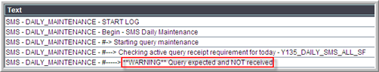
Figure 29 - Warning log contents
In this case the BW query has not arrived in time, thus the alert is raised. Other warnings may include:

- No active recipients for a profile
- No active filters for a profile
- No active messages for a profile

SMS Reporting – Recipient Audit
The recipient audit is generated from the SMS_PERIOD_MAINTENANCE job. The audit should be used to identify any users who should no longer be receiving the SMS messages, for whatever reason.

SMS Reporting - Recipient Audit Report - 2009/09/28
Code | Name | Mobile | Email | Status
GIRLIJON | Jonathan Girling | +61407232824 | jonathan.girling@ap.effem.com | Active
GREGASTE | Stephen Gregan | +61418985447 | stephen.gregan@ap.effem.com | Active
KEONTRE | Trevor Keon | +61404037923 | trevor.keon@ap.effem.com | Active
LIJOY | Joyce Li | +8613980808081 | joyce.li@ap.effem.com | Active
RUICHE | Chen Rui | +8613910711727 | chen.rui@ap.effem.com | Active
WUKEL | Kelly Wu | +8613601083860 | kelly.wu@ap.effem.com | Active
ZHAOPAT | Patricia Zhao | +8613601383150 | patricia.zhao@ap.effem.com | Active
Table 40 – Recipient Audit

Support FAQ
This section covers common questions with regards to the support of the China SMS system.

How do I view the SMS pages in ICS?
The AP GSM Service Desk team are responsible for managing access on every ICS installation. A magic incident needs to be raised to that team requesting access to the China SMS Administration pages. An example request would be as follows:

Hi Service Desk,

Please grant access for the below user to the China SMS Administration webpage’s on AP0115P. The menu item is SMS_ADMIN. The user details are:

Name: Trevor Keon
5/3: KEONTRE

The magic incident should then be forwarded to the GSM_SERVICE_DESK_AP magic group.

SMS messages not received, how do I find the cause?
There are a number of points of failure where the message may have failed. This point needs to be identified, so follow the Support Structure to identify this. Some known causes are listed below.

Error sending messages
Check the ICS Logging page and check if there are any error messages for all report generation jobs. The error could be something simple, like a space in the phone number of a recipient (refer to Recipient Maintenance).

Error in Notes Agent
The notes agent may not have processed the incoming emails from BW successfully. A magic ticket should be raised to the GSM Service Desk group for them to investigate any possible errors in the Notes Agent.

How do I stop messages sending on a public holiday?
To stop the SMS messages sending on a public holiday, go to the System Control ICS webpage and stop the system. Note that this will prevent any message from sending until the system is started again, so this should be done the day before the public holiday, and after the SMS messages have been sent on that day.

Why doesn’t the total match the contents?
This can be caused by a number of issues. Check the following:

Check BW
Contact the BW dispatcher and get them to assist in checking the report. Give them the query name (e.g. Y135_DAILY_SMS_ALL_SF) so they can quickly give you the link to view the report on a webpage. Note that you will need access to BPP before you can view the report.

Message Structure
The structure of the SMS message (refer to Message Maintenance) and the filters (refer to Filter Maintenance) may cause this issue. You cannot filter on the dimension that you display the total from when the child has multiple values. For example:

The users receive the message below.

MT ( BJ ) P10W4D1
C ( 6420K + U16424K )
TOT ( 9337K + U21198K )
Table 41 - Incorrect message

The filter used is as shown below.

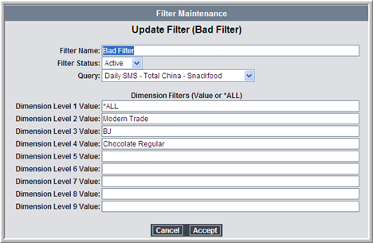
Figure 30 - Incorrect filter
The filter is only showing “Chocolate Regular” for dimension 4 (BDT). If BJ (Beijing) in the Modern Trade sales team has more than 1 BDT then this message will not show the correct total value. The result of the query is shown below.

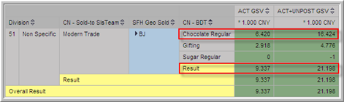
Figure 31 - Query Result
To fix this issue, the dimension level 4 filter would need to be changed to show all values. The other option would be not to show the total values for that message.

Why can’t I see a total line for some items?
There are two possible causes for the total lines not showing.

Total not defined
Check the message configuration (refer to Message Maintenance) and ensure the message has a total entry for the dimension.

Single value in total dimension
Check the message configuration (refer to Message Maintenance) and ensure the message does not have the Total Text Options set to "Multiple children totals only”.

Why hasn’t the SMS message been sent when ICS has processed the query?
There are a number of prerequisites before a message will be sent after ICS has processed them.

System stopped
Check the System Control ICS webpage to see the current status of the system. If it is stopped, the query should be in the queue pending processing.

Before broadcast time
Check that the current time is not earlier than the SMS Broadcast Time (HH24MISS) system setting. The query will be pending in the queue until this time is reached. You can confirm this by checking the System Control ICS webpage.

Subsequent send for the day
Check if the query was not the first send for the day. The system will not automatically process queries if they have already been sent for the day. To force the messages to be sent, refer to the Report Execution ICS webpage.

